The Equity-Driven Systems Change (ESC) Model and Process
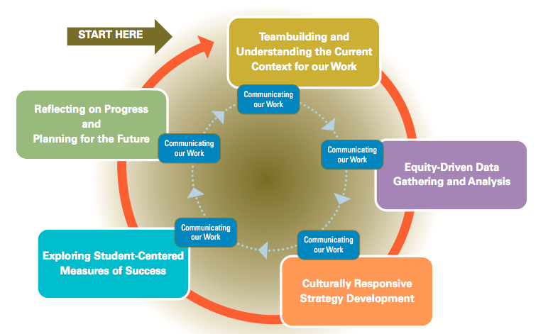

Stage 1: Team Building and Understanding the Current Context for Our Work
February 22nd 2011-September 27th 2011
During this phase of the process, the SEEED Committee is just forming and beginning to build trust and connectedness so that they may engage in authentic dialogue and effective ongoing work together. They also analyze the current context for their work, including looking at strengths and challenges they face in developing and moving forward an equity agenda at their college. It is critical at this stage of the planning process that the team builds safety and that all are on the same page about the purpose of their work.

Stage 2: Equity-Driven Data Gathering and Analysis
October 26th 2011-April 27th 2012
During this phase, SEEED Committee begin to look at the college’s student outcomes data relevant to the overall focus question for the planning process. They then develop inquiry questions aimed at answering their focus question and break off into Action Research Teams to develop and implement data-gathering plans. Finally, they report back their key findings and begin to make meaning of the data.

Stage 3: Culturally Responsive Strategy Development
August 24th-25th 2012
At this stage, the SEEED Committee is ready to move into the development of an overall vision for student success that propels them into action. It includes visioning, identification of “contradictions” or barriers to the vision, and the development of culturally responsive strategies to address the contradictions and move the college closer to its vision.

Stage 4: Exploring Student-Centered Measures of Success
September 25th 2012 – Current
At this stage, the SEEED Committee broadens out to include the involvement of additional individuals and teams responsible for implementation of strategies. This stage includes identification of two- to three-year measures of success for each strategy, an assessment of the current context related to the strategy, and the development of Year 1 actions.

Stage 5: Reflecting on Our Process and Planning for the Future
The Future
During this stage, the college is ready to look at evaluation data showing the progress of their strategies and determine which strategies should be grown and which may require course correction. This stage includes the involvement of all those directly responsible for implementation.

