DIGITAL ACCESS SURVEY NAME___________________

- Android or iPhone?

- Is your school email connected to your phone?

- Do you have a YouTube app?

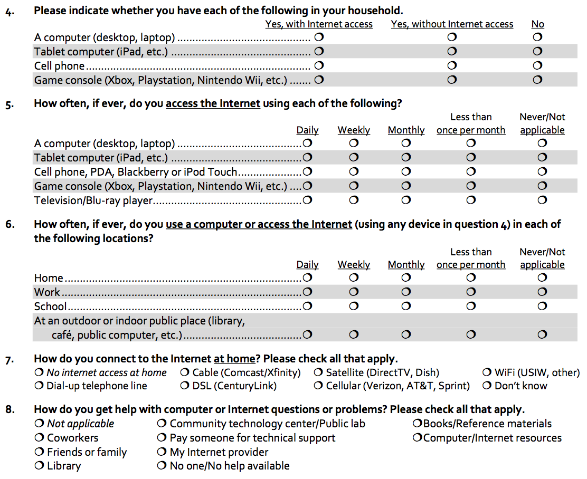

BUT WAIT, THERE’S MORE ON THE BACK….
