- Go to the SMCCCD Employee Portal and login with your SSO credentials:
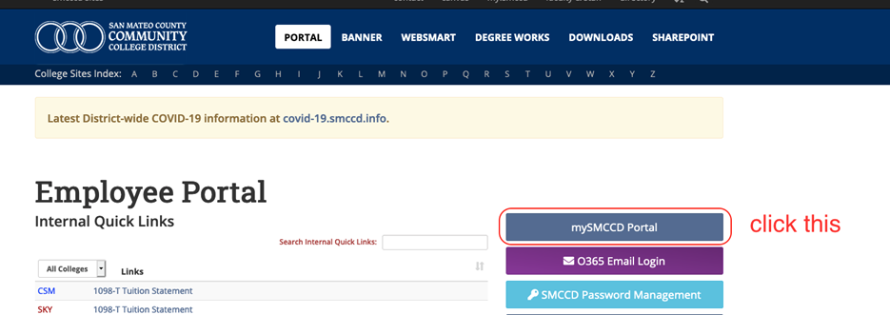
- After you enter your SMCCD credential you will see this page; click the Vision Resource Center tile:
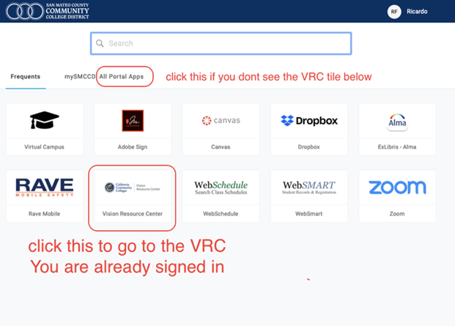

- Once there, click the Events Calendar Button link to go to the desired date. | 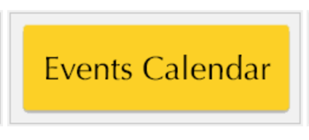
- Click the name of the session and  - Register by clicking the “Request” button. | 
You have now registered for the session. You will receive an email confirmation from skylinecttl@smccd.edu.

If you experience any issues, please contact Ricardo Flores (floresr@smccd.edu)

