TIPS FOR CREATING SEP’S ON DEGREEWORKS
Skyline College Counselor Training
April 22, 2013

Basic DegreeWorks and DegreeWorks Education Plan Instructions are available on the Banner Portal Training page:
http://appserv1.smccd.net/Documentation/Degree%20Works%20Counselor%20Instructions.pdf
http://appserv1/documentation/DegreeWorks%20Planner%20Instructions.pdf

This handout includes additional instructions for the following functions:
- Find Student
- Recommended SEP Descriptions
- Using “What If” while in SEP mode
- Print
- Emailing SEP’s

By the end of this training, counselors will be able to:
- Create a simple SEP using DegreeWorks
- Use the what-if function while in the SEP screen
- View and print the SEP

Why am I the trainer today?
When the district first adopted Degreeworks a couple of years ago, Jacquie and I, along with counselors from the other 2 colleges, were invited to test it and give feedback on it to the programmers. Even though I was familiar with it from all of the work we did on it, when it was first released to counselors last year, I found it extremely frustrating. I made lots of mistakes, constantly getting errors and forgetting to save things. And the first time I tried to email it to a student, it took me at least 15 minutes and I was frustrated again. So if any of you have tried Degreeworks and have found it difficult, confusing, or frustrating, I absolutely sympathize. Even after using it extensively this year, I still get frustrated with it. So the reason why I am the trainer today is not because I am now an expert. I am not. It’s not because I even like it, because I don’t really. I am the trainer because I happened to have used it more than most counselors here, and consequently have made more mistakes than anyone else. This really is a lesson on how to avoid my mistakes!

Why use DegreeWorks for SEP’s?
- Enrollment management tool
- Automatically updates student registration priority on Banner
- Eliminates need for uploading SEP’s on Webextender
- Quantifies part of the work counselors do
- New Student Success Initiative ties part of the funding of colleges to SEP’s
- Students like having easy access to their SEP’s

An important caveat before we start.
Sometimes we think that because something is computerized, it must be accurate. Remember that the information in it was scribed by real people. Sometimes there are errors in scribing, sometimes there are errors in the program. When one piece of information is entered in, sometimes it inadvertently affects another area in the program.
Degreeworks is only a tool, just like the CSU/IGETC paper sheets that we have. People working on it do their best to be as accurate as possible, but mistakes can happen. As counselors, we need to be familiar enough with our courses, our curriculum and our rules so that if something seems off, we can investigate further and make adjustments if needed.
ONE MORE THING! Because you are going through the training today, you will be getting a little extra help so that you can get used to the Degreeworks program. More on that at the end of our session.

Today we are using TEST ID’s so that you can play around with SEP’s and not be afraid that it will affect a real student’s record. However, before you can get into the system to use the Test ID’s, you have to use a real student’s G# to enter in the system. I am giving you some real students’ G#’s only to enter the system. Once we get into Degreeworks, we will enter in the G# for our test students, and we will use those for our training.

Starting up Degreeworks:
Enter in your own G# and password – advisor services – degreeworks – term-enter student G#

FIND STUDENT
If you are already in DegreeWorks, but need to change the student you are working with and have a G#, you can go directly to the Student ID section to change the student G#. If you don’t have the student’s G#, you can use the Find Student function:
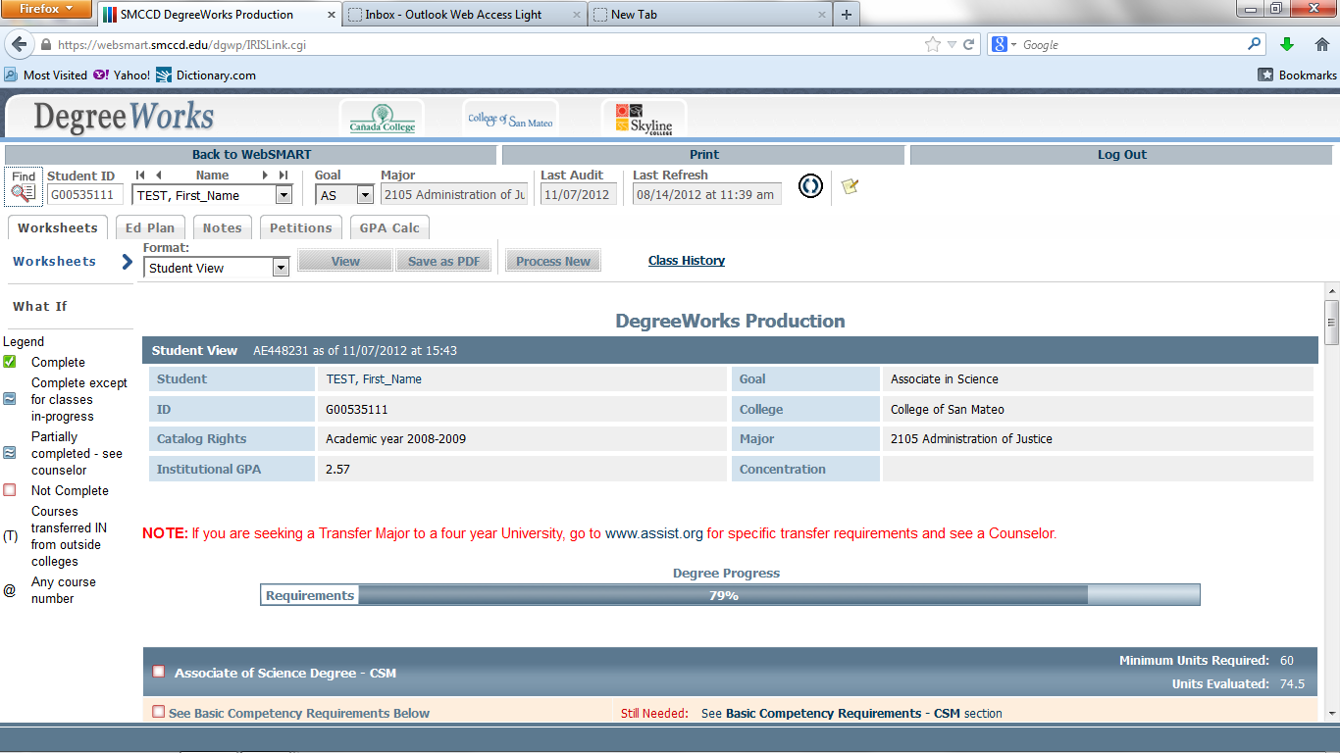
Click on the  button and a Find Students screen will pop up.
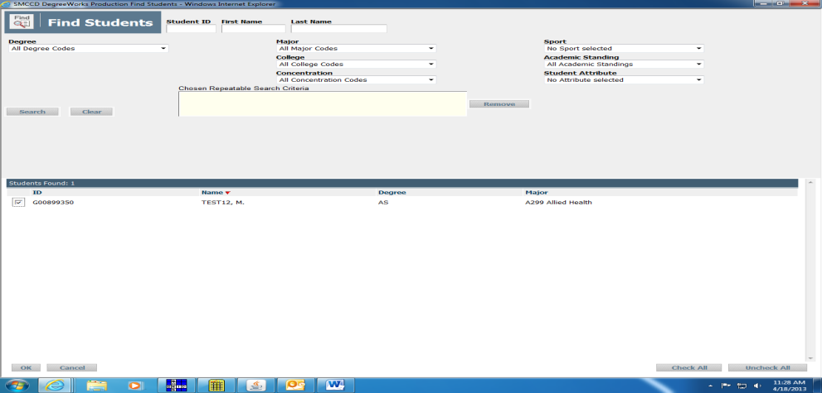
- Enter the new student’s information
- Click on Search
- If this is the correct student, click ok.

DegreeWorks Education Plan (Planner) Instructions
The DegreeWorks Planner allows counselors and advisors to create, view, and save course plans for students.

Creating a Plan
The DegreeWorks Planner has two main parts: the Planner Worksheet and the Student Educational Planner on the right. The Planner Worksheet is a smaller version of the original audit that shows how a student’s planned courses apply to the degree requirements. The Student Educational Planner is where the planned courses for each term are entered.

Open the Ed Plan tab to start a new plan. In the Student Educational Planner area to the right, enter a description and select the student’s catalog year. While a description is not required to view plans in the Planner Worksheet, it is later used to save the plan.

Note that in the SEP, the date you select is actually Academic Year rather than Catalog Year, since it does not let you select anything earlier than the current year.

The Description box is bigger than it appears, so it is possible to enter in a lot of information in this box. There is also an even bigger Comment Box that is at the bottom of this planner. When the student views the SEP, it actually moves everything in the big comment box right to the top portion of the SEP so that it becomes more prominent. When we had the paper SEP’s, we had a lot of check boxes that we could use to help us standardize the SEP’s. Unfortunately, the degreeworks program does not allow us to add this feature, so we just have the big text boxes instead. Jacquie has put together a recommendation of what we may want to include in these boxes so that information on our SEP’s is more standard.

The “Active Plan” checkbox indicates whether the plan is active or not. “Active” means that it is the SEP that is entered into the Banner system and is also the first SEP that shows up when you open Degreeworks, if a student has more than one SEP. The “Locked” checkbox prevents a student from modifying the plan, but because students cannot create, modify, or delete plans at SMCCD, the box is currently invalid.

You can see if a student has more than SEP in the system. You can build on what is existing, or create a new one.

Note: The “Current Term” refers to the last semester of a student’s active registration, so it may or may not be the actual current term.
Semester Selection
To begin creating the plan, select a semester term from one of the drop down "Select
Term" areas. Only the current or future semesters can be planned for.

One drawback of this SEP is if you forgot to include a semester and write a whole plan out, you can’t go back in to enter in an extra semester without retyping. So I always check, are you sure you don’t want a summer session in here? Do I need to put in the current semester before writing in the rest of the SEP?

Adding Courses
Add the subject and course number of the planned courses to the fields in the left column and the credit values to the right. Only one course can be applied to each line. Courses can also be added by clicking and dragging the course directly from the Planner Worksheet to the Student Educational Planner. In the example below, HIST 108 was manually typed and ENGL 100 was added by dragging the course from the audit

When you manually type a course in, the course identifier MUST match Banner. If not, it will not be recognized when you try to save the SEP, and a little red arrow shows up telling you something is wrong. If you see the red arrow, it doesn’t mean that the course doesn’t exist in the system, it just means that you didn’t type it in right. My common errors are remembering Sociology is Soci, Music is Mus. And Business is Bus.

Course Placeholders
Often times, students may select from a list or range of courses to fulfill a requirement. For example, the General Education Requirement for Oral Communications may be completed with one of four courses. We are unable to include a list or range of courses in Planner, but we can add placeholders for requirements of this type. To do so, simply add a dash ‘-‘ in front of the requirement. The dash tells DegreeWorks that we are not looking for valid course in Banner. These courses are not included when you run an audit. You also need to enter in units if you want an accurate unit total.

When this handout was first created, the default view for the SEP was calendar mode. After counselor feedback, the default was changed to Note. This mimics more closely to what we often did when we had paper SEP’s. In this example, if the student needs a course for Oral Communication GE, I usually enter one course in the SEP, like Comm 110, but in the Notes box next to it, I will write “can take Comm 110 or 130 or 150” so the student will know they have choices.

View the Plan in the Planner Worksheet
After the courses and terms have been added, select the checkbox next to each term and hit the “Process New” button. The planned courses will now appear in parentheses in the Planner Worksheet, indicated by the PL and Planner text. Note: The “Check All Terms” and “Uncheck All” buttons may be used to
select the terms to display in the Planner Worksheet. The “Check All Terms” button will include blank terms, but it will have no impact on the audit.

Because the “ADAP 348:359” are only used as placeholders, they are not available to fulfill requirements in the Planner Worksheet. Instead, they pull into the "Not Counted" section near the bottom of the audit, as they are not valid courses in Banner. Once a student has decided which course they would like to complete, the plan can be updated to pull in the specific course.

Saving Plans
Select the “Save Plan” button to save the plan. Once the plan is saved, you will be able to select it form the drop down menu near the top of the Planner Worksheet. To save an additional plan, you can either start over by selecting “Add new plan” from the drop down menu and reloading the audit, or click the “Save As…” button to save any changes in a new plan while preserving the older one. “Save As…” will prompt a new window that allows you to save the new plan with a new title. Be aware that changing the description and clicking “Save Plan” will not save a new copy of the plan – it will override the current plan. Note: The “Reload Form” button will reload the last saved version of your plan.

Remember I told you this was all about avoiding my mistakes? One mistake I made frequently in the beginning was NOT remembering to save before I went to view the SEP. I have created complex SEP’s and forgotten to save it, then lost everything when I went to view the SEP. Now I am a little paranoid about saving, and save often!!!

Show Completed Classes
Students may enroll in courses other than what was listed in their plan. To view the courses that the student is currently enrolled in to the Planner, check the “Show completed classes” checkbox and reload the form using the “Load” button.

The courses that the student is enrolled in will now pull into the Planner but we are unable to see this feature because there are no old plans in the system.

Planner Modes
The Planner offers three different views types, also known as modes. The Calendar Mode is the view that was used to create the above plan. This mode also provides the plan comments and signature lines for student and counselor

The Notes Mode is used for saving notes that may apply to each semester:

The Planned vs. Taken mode compares planned courses with the courses that have been completed or courses that the student is actively registered in. Although there is a note stating that “only completed terms are evaluated”, in-progress courses are included.

What If in Planner
Planner can also be used to plan courses in What If audits. Currently, Jessica is in the AS Early Childhood Education, but let’s assume she plans on changing to the AS in Family and Consumer Sciences. On the Planner Worksheet, select the “Show What If Options” button.

When selecting what-if’s, it is important to remember the student’s catalog rights. You can use any audit beginning from the student’s catalog year OR any audit AFTER that year. Sometimes we have new majors, like the AA-T/AS-T degrees. The student may have catalog rights to a year before we had those degrees. When you do an audit then, you would need to change the catalog year so that you can see the correct degree requirements.

The What-If can be very helpful in viewing the GE requirements for CSM and Canada too. Remember that we have have the policy of Reciprocity. If a student can choose to use any of the 3 AA GE patterns in our district, and we will honor any of them.

When you select a criteria, it will show up in the “Chosen Areas of Study” box. Make sure that the criteria you are using is correct. Sometimes if you do more than one audit, your old criteria stays in that box and you get a strange audit. To remove something, just select it and press remove.

Complete the What If fields as you would for a regular audit and select the “Use What If Scenario” checkbox. Select the terms on the saved plan, and “Process New”.

After the new audit is processed, the "Hide What If Options" button will need to be clicked to view the What If audit with the planned courses. The Planner Worksheet now pulls in the Small Business Administration requirements, along with the planned
courses.

Some things to note on the audit itself:

Sometimes I use the what-if before I start the SEP. When I switch to SEP mode, the system automatically reverts back to the official audit that shows up when you first open degreeworks.

The GPA that shows up on Degreeworks is the institutional GPA, not transferable GPA.

Read the audit carefully. It does note the residency requirement, but in very small print.

NOTE: The Planner Worksheet only shows the planned courses for AA degrees. The courses do not show up in the CSU GE or IGETC worksheets. They only show up if the student has registered for the courses, not if they are simply planned in your SEP.

USING WHAT-IF in SEP MODE

In order to use the What-If function while creating an SEP, you must have at least one semester checked on the SEP and one course listed.

- Choose “Show What If Options” and complete the “What If” fields.
  - Note: Some of the majors, like Interdisciplinary Studies, require that you select the major under “Concentration” too. You will not get an accurate degree audit if you don’t select it.
- Check your choices under the “Chosen Areas of Study” Box.
- Select “Process New”.
- Select “Hide What If Options”.

SAVE before you switch to “view”

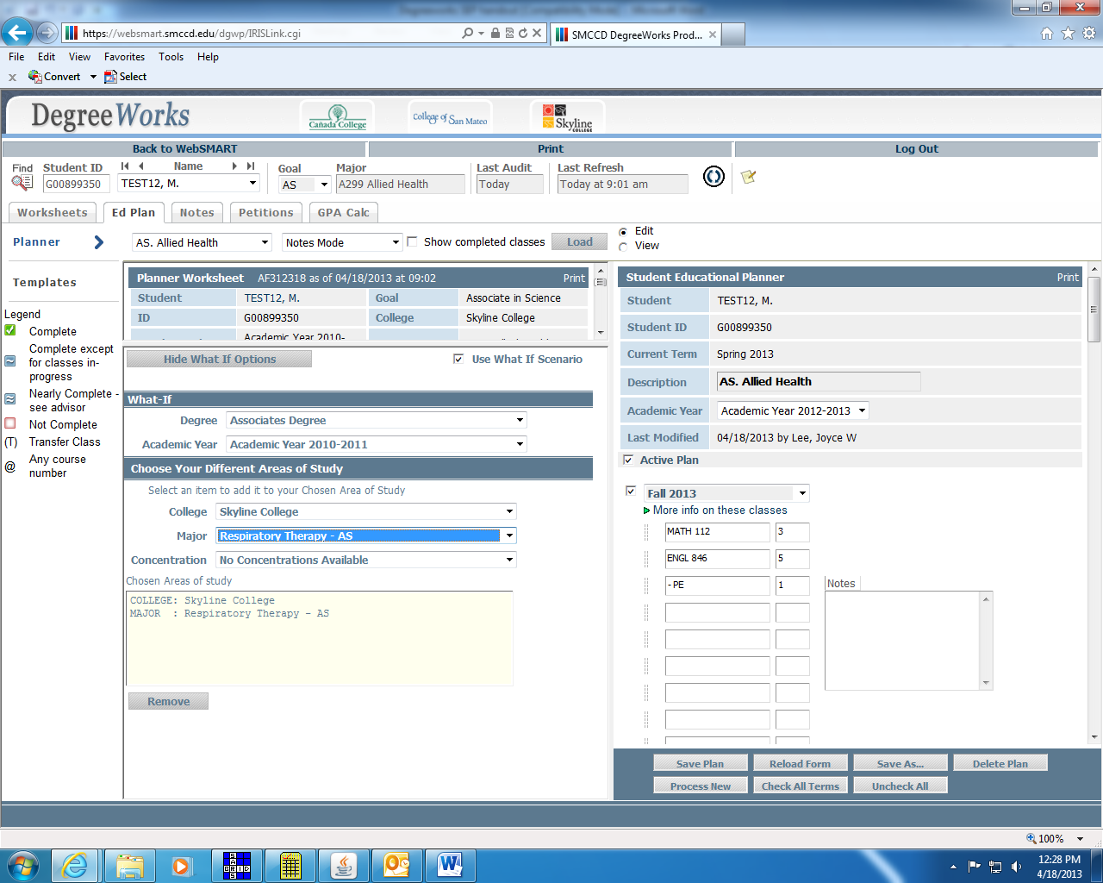

TES/AP/HS-LOTE
As more students are using the District Transcript Evaluation Service, you will start to see more of those evaluations showing up in your degree audits. You may see one of two notations in the audit. If a course taken out of district is equivalent to one of our district courses, you will see the course in the audit with the actual course number. If the course is not an exact equivalent, but meets the criteria, for example in the CSU GE, it will also show up in the audit but with a special identifier so you know it is not an exact equivalent. You will also see AP exams and for students completing the language other than English requirement on IGETC with high school courses or other method, those are being entered into degreeworks too.
Remember that the information on this degree audit only tells us how our district will use these courses either toward our degree or toward CSU/IGETC certification. It does not mean that other schools outside of our district will use them the same way! For example, when looking at an AP exam, we may be able to use the AP to certify an IGETC area, but if the class is part of the student’s major, the transfer school might say the AP exam is not enough to satisfy that requirement. (Ex. Score of 3 on Calculus AP satisfies IGETC, but does not meet major requirement for many students transferring as Econ or Engineering majors.) In future trainings, we will be talking more in-depth about how to figure out what works for transfer, but for now just keep in mind that the degree audit only shows how we will use it, it has no implications for how a transfer school will use those same classes or test scores.

To view your SEP in the format that students see AND to print, go to VIEW. REMEMBER TO SAVE before hitting VIEW! The view shows what the student sees when they go into degreeworks. They will not have the split screen that we have.
PRINT
1. Check to see that the screen shows what you want printed.
2. Select Print at the top of the page, under the Skyline College logo.
3. Select printer and print.

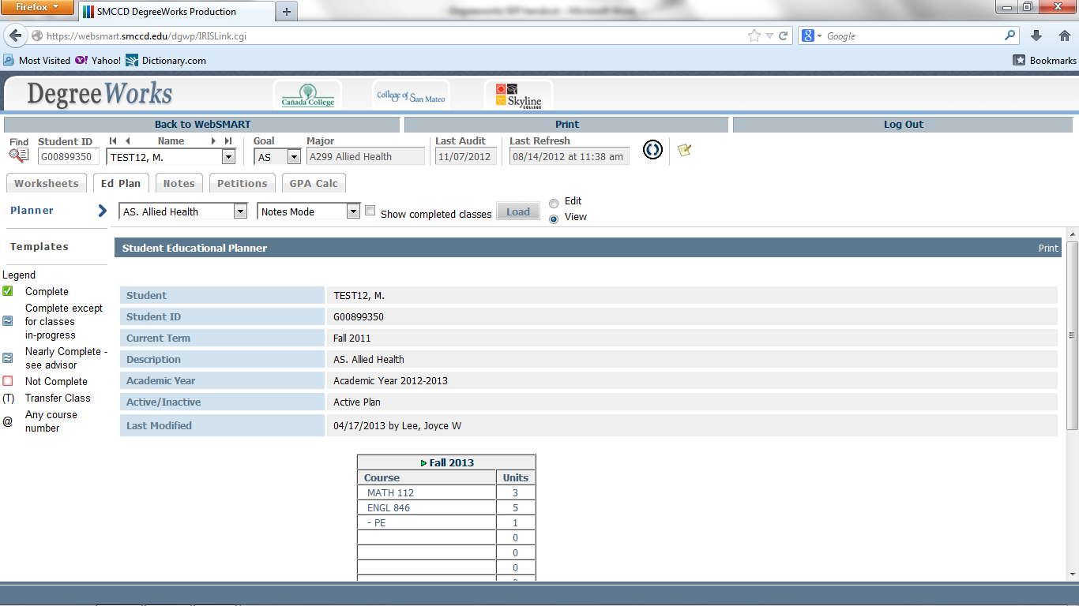
EMAIL

When I first started using degreeworks, I would show students how to view their SEP’s, but they were often nervous that they couldn’t get back in so they wanted print-outs. After using a ton of paper, I realized that I needed to figure out a way to email the SEP’s to students so that I could stop printing. Like I said, the first couple of times took a lot of time, but now that I am used to it I can do it in a minute and students are really happy since they can see their SEP without having to go through the trouble of logging into Websmart.
- From the Print screen, select Adobe PDF.
- The PDF will open up on your screen. Save the PDF, checking to see where your file is located.

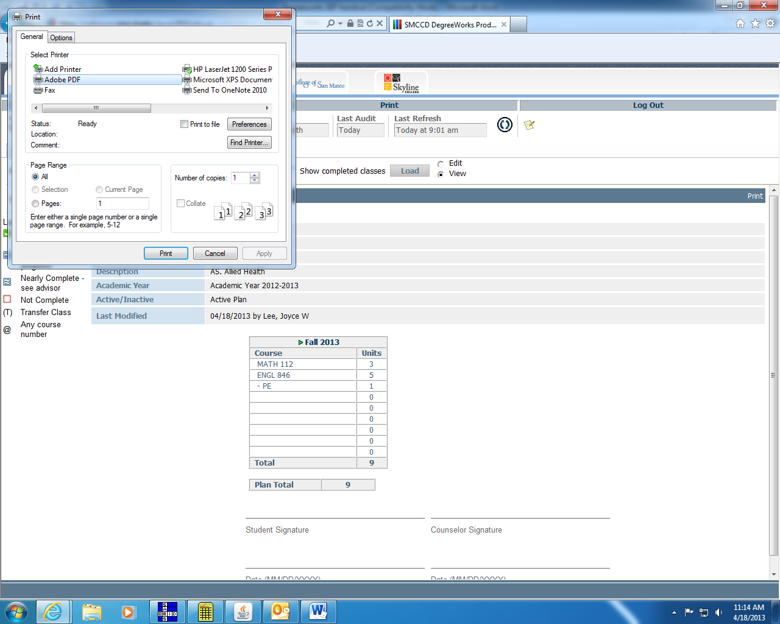

3. From this screen, you can print in one of two ways:

- Go to File, then “Attach to Email”. The side screen will pop up. Select Attach, and you will be directed to your email. Enter the recipient’s email address and send.

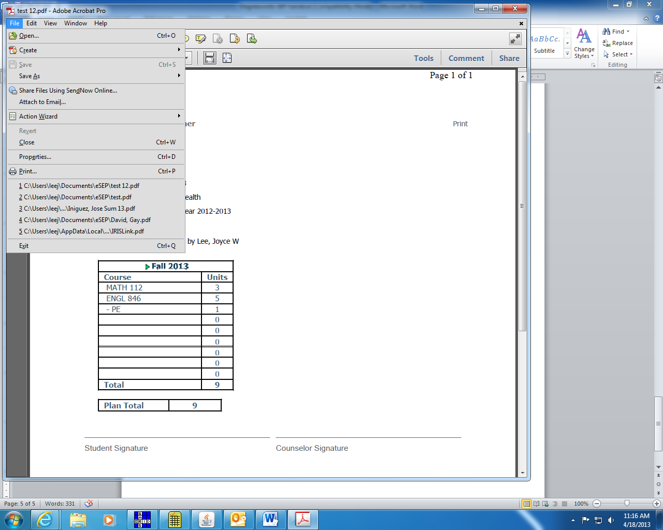

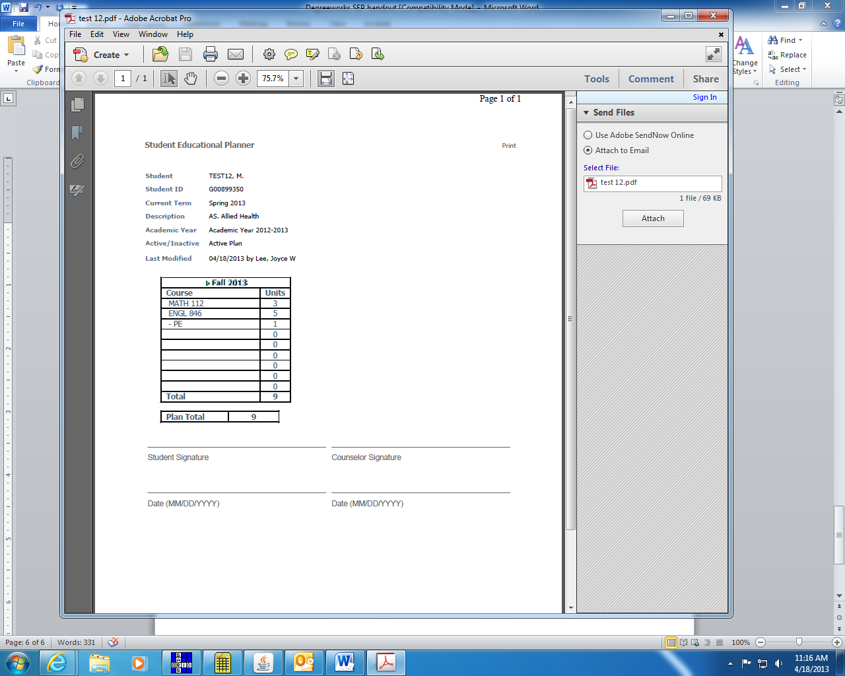

- Alternatively, after you save your PDF, then CLOSE the PDF. Open your email and create a new message. Add the PDF as an attachment.

